**CSE 212 – Programming with Data Structures**

**W01 Prove – Response Document**

| **Name:** | sofia galkina |
| --- | --- |
| **Date:** | 02/05/2024 |
| **Teacher:** | Luc Comeau |

*It is a violation of BYU-Idaho Honor Code to post or share this document with others or to post it online. Storage into a personal and private repository (e.g. private GitHub repository, unshared Google Drive folder) is acceptable.*

**Question 1: For the rotate right problem, provide a description of how you solved the problem.**

there has to be some sort of a variable to be the indicator of where we need to start the iteration for a new array to be form with the right value at the address of 0 in this new list. this can be done by taking the length of the list (will always be 9 because all our test cases are numbers 1-9) and subtracting the number that the program gives us as the number where we need to start rotating. then find the residue of division between the first number and the length of the list (which is 9 again). We use modulus to make sure the index is within the range of 9 and is not negative and not a float like 0.08.

**Question 2: For the rotate right problem, draw a picture of how you solved the problem.**

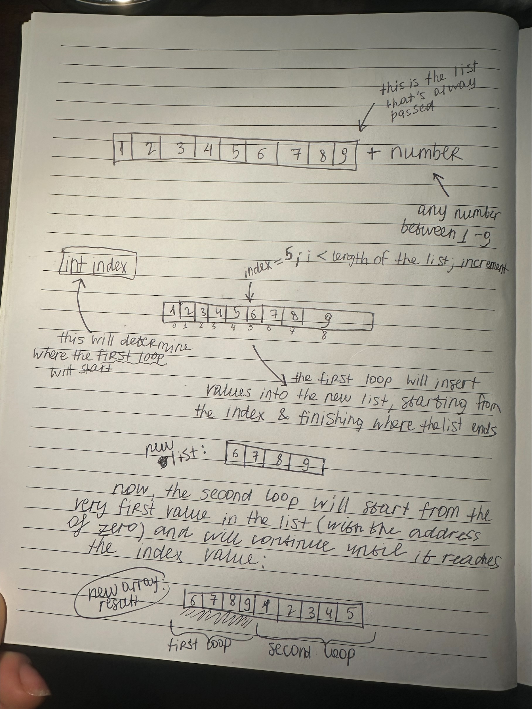

Remember: You need to commit all the changes to the prove-01-<username> repository along with this document. Then submit a link to the repository in I-Learn.